Vantage intake and orchestration: summary
Stephen Costello · Credit Risk Review · 18 September 2026 · Companion to the concept paper
One intake, two lanes, one orchestrator. Files are classified by content shape at upload: documents flow through DEEP; tabular data (CSV, Excel) flows through a profiling path built for it. At question time a planner routes each question to the cheapest machinery that can answer it with receipts. The same construction serves a three-column tracking sheet and portfolio-wide scenario screening, and the tailoring per use case lives in configuration, not code.

Why tabular data needs its own lane
A CSV is not a document; it is a database that has not been loaded yet. Meaning lives in the schema and in relationships across cells, so embedding raw rows produces near-identical vectors, cannot answer computed questions ("how many", "what share"), and is slow and expensive at scale. The fix is to route by question kind: the LLM stops reading the content and starts writing the program that reads it.
Question kind | Example | Right machinery
Computational | "Nominal and % of portfolio exposure with customer concentration above 20%" | LLM writes a query; DuckDB executes it deterministically
Lookup / fuzzy match | "Find the entry about the watch supplier" | Hybrid search over selectively serialized rows
Semantic over free text | "Which comments mention covenant concerns?" | Embed the text-rich columns only; structured columns become filters

Intake: everything expensive happens once
At upload, a content-shape classifier assigns each file (or sheet) to a lane; extension is only the prior. Tabular units are profiled into a schema card (column roles, types, cardinality, language mix; a few hundred tokens regardless of row count), the analyst confirms the interpretation once, and semantic units are constructed from free-text fields plus disambiguating row context under a versioned Semantic Unit Specification, then embedded with one multilingual model. The index is a derived, rebuildable artifact; the uploaded file stays the authoritative data.
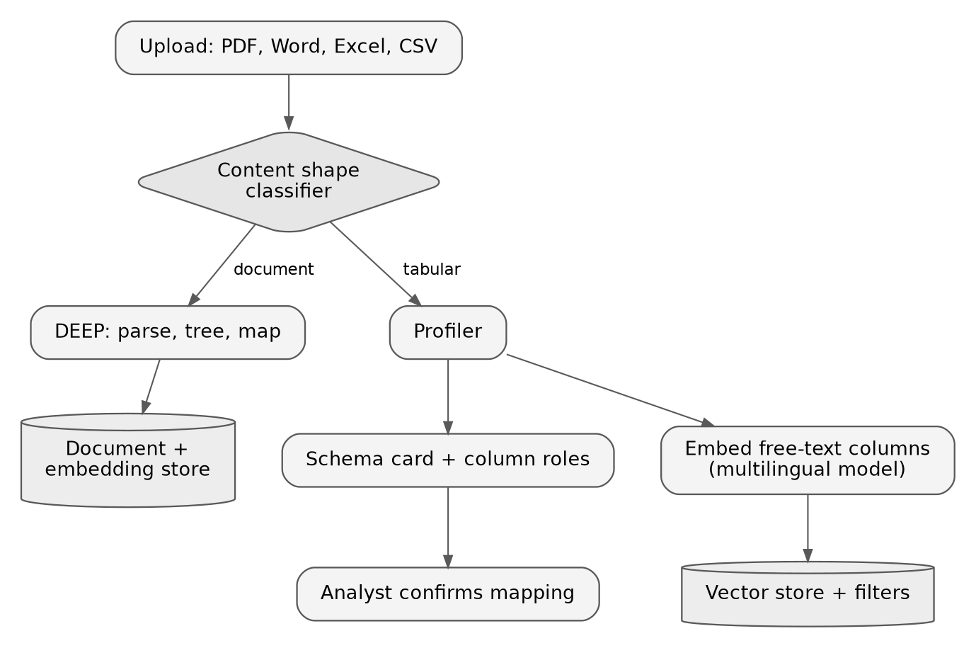
 | Document lane | Tabular lane
Inputs | PDF, Word, narrative sheets | CSV, Excel sheets, table-extract PDFs
Structure | Recovered by DEEP parsing | Given; captured as a schema card
Search | Hybrid over chunks | Query over columns + semantic over text columns
Provenance | Document, page, source text, location | Executed query, returned rows, classification table

Question time: a router, not a pipeline
The planner reads the cached schema card and dispatches only what the question needs. Stated predicates that map to columns go straight to SQL. Judgment terms ("impacted by rare-earth tariffs") trigger two independent passes run in parallel: a categorical pass over distinct values (which prioritizes but never excludes; banks, funds, and holdcos land in an indeterminate tier by rule) and a semantic pass over all free text. Their union is adjudicated per row with a text-grounded reason, producing three tiers: exposed, not exposed, and indeterminate, the last reported as a quantified caveat beside the answer. Analyst edits to the classification table re-run only the deterministic aggregate.
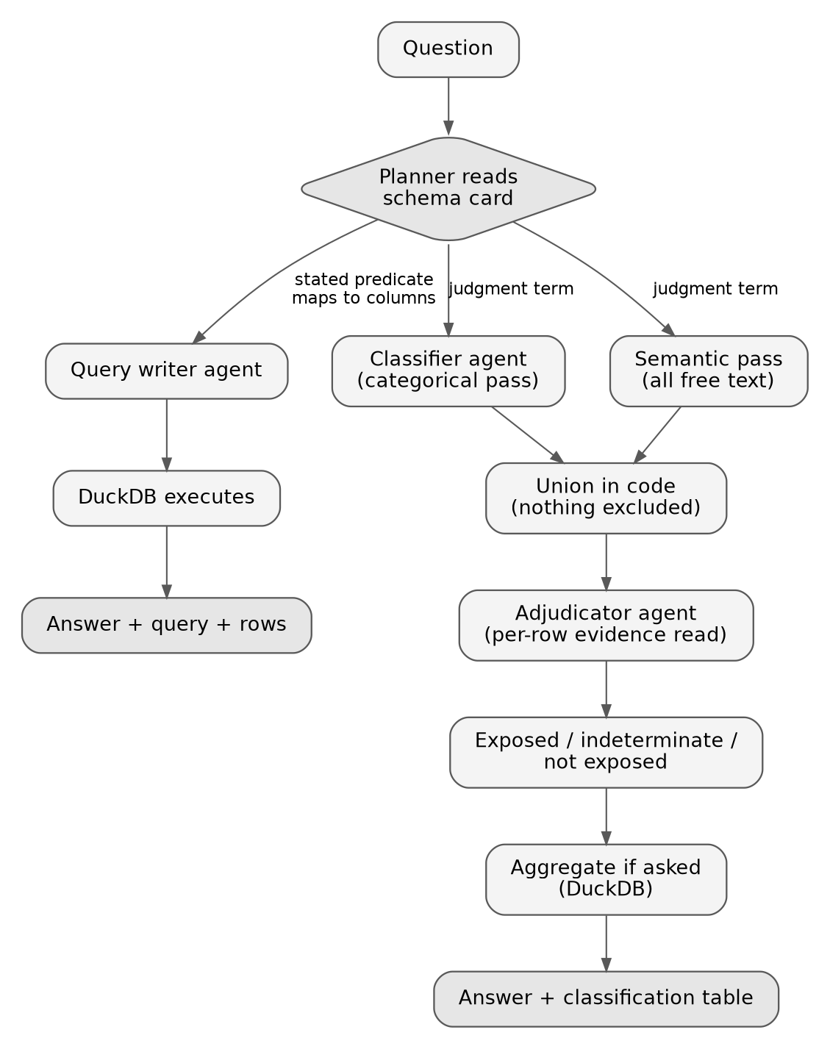
Exactly four LLM judgment points exist; everything between them is plain, auditable code.
Agent | Judgment | Artifact
Planner | Which machinery the question needs | The plan, shown with the answer
Classifier | Categorical pass over distinct values, concept-level | Tiered value classification
Adjudicator | Evidence-backed call per candidate row | Reasoned call per name, editable
Query writer | Translate intent to SQL | The query, executed deterministically

Why it is safe
- Every answer ships with receipts: the executed query and returned rows for computed answers; the plan, tiered classification, and per-name reasoned calls for judgment answers; the confirmed schema mapping and specification version for both.
- Nothing is excluded by a model judgment alone; the only route out of scope runs through the adjudicator with a reason.
- The file's silence is quantified, not guessed over, matching the platform rule that an untraceable answer does not enter a deliverable.
- Evaluation is sliced per language (DE/FR/IT/EN) and per question kind; ambiguity (unmappable terms, mixed currencies) escalates to the analyst.

Status
- Decided: the schema card is a first-class platform object, cached and reused; the content-shape classifier is a central service-layer capability invoked per use-case configuration, with profiling starting asynchronously at upload.
- Decided: uploaded tabular files follow the same intake permissions shape as documents; open whether those attributes and tabular artifacts are retained in the central storage layer or only application-side.
- Open: confirm the embedding model is multilingual and request the per-language retrieval evaluation.
- Open: integration shape for the PICH rating-database check (export and join vs. governed connector).
- Deferred: risk-posture configuration fields, candidate for a 2H27 release.

